Day 1 and Day 2 Revisit

* Spring Framework – It’s a Framework used to create loosely coupled Enterprise Java App
* It’s mainly depends on IoC and DI (Managing Bean life cycle & injecting it to the app)
* IoC – Inversion of Control
* DI – Dependency Injection
* Core, WebMVC, Test, Security, AOP, Data
* Constructor Injection & Setter Injection
* Bean Configuration – XML configuration, Annotation Configuration ( Adding Annotation in Java class)
* Resource & Bean Factory and using Application Context – IoC Container
* Installed Softwares STS, EclipseLink, MySQL 8.0.x server and all tools, Postman, Git
* JPA – Java Persistence API (It’s a Specification – defined in adv Java concepts)
* JPA Implementation – Hibernate, EclipseLink, iBatis etc.,
* JPQL – Java Persistence Query Lang (DB Independent Queries – Queries using Entity Bean class name rather than using the Table name)
* CRUD operation using EclipseLink
* Persistence & Serialization
* Serialization – Is the process of Storing the state of an object in a flat file (.txt, rtf, .doc etc.,)
* Persistence – Is the process of Storing the state of an object in a DB entity (table)
* Hibernate – Is a popular ORM Framework (ORM – Object Relational Mapping)
* Hibernate – hibernate.cfg.xml & <entity>.hbm.xml (hibernate entity bean mapping file)
* Eclipse Link – EntityManagerFactory, EntityManager (Begin Transaction & Commit Transaction)
* Hibernate – SessionFactory, Session

DAY 3 Agenda – GIT

<https://git-scm.com/>

SCM – Software Configuration Mgmt or Source Code Management Tool

Version Control System –

GIT – Popular Free & Open Source Distributed Version Control System.

Open Source Software – (Source code is also available for free of cost) – Linux (RedHat Linux, AWS Linux, Oracle Linux, Ubuntu, Suse…)

Proprietary Software – Download & Install (Exe, ZIP) – Charges (Pay & USE)

Linus Torvalds – Created Linux Kernel and GIT

Git can be used in CLI format and GUI Format

CLI – Command Line Interface – Command Based (Needs to know the commands & it’s usgage)

GUI – Graphical User Interface (Buttons & Clicks, Drag and Drop) – No need to have the git commands knowledge.

Git clone <git_repo_url>

Git Architecture

Local Area (Working Directory)

Staging Area (Temp Area)

Remote Area/Cloud Area – (Online Repository – Container to store all the code along with it’s change history) (Remote Directory)

Installing GIT

<https://git-scm.com/downloads>

Open the Installer and follow on-screen instructions (Make sure to select the default editor as Notepad or Notepad++)

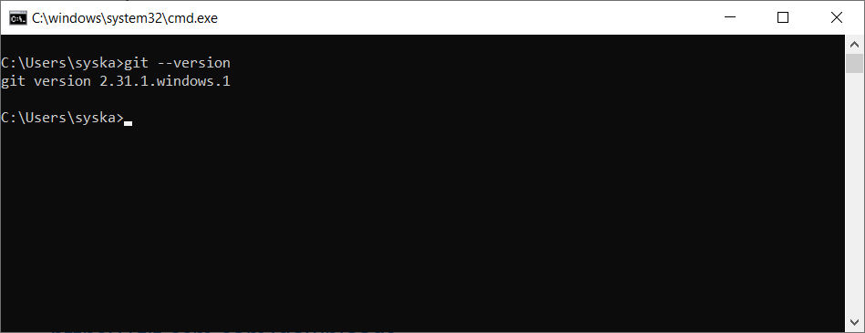

* Workspace (The Folder where your project resides – A folder location in the file system)
* Staging Area
* Local Repository
* Remote Repository

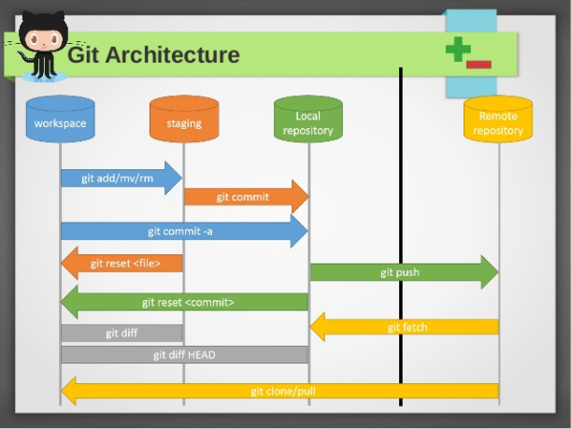

DOS (Disk Operating System) Command Prompt

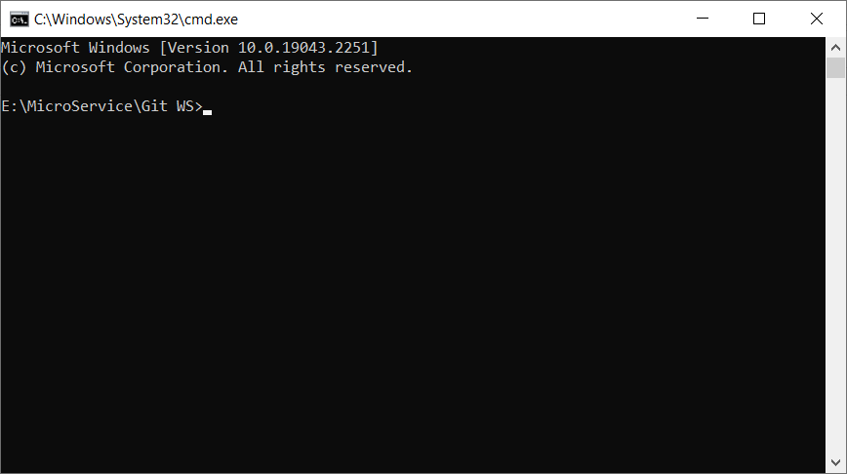

Git Bash Command Prompt

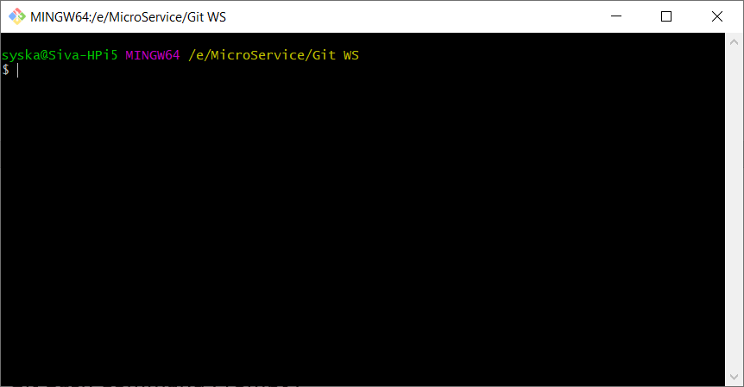

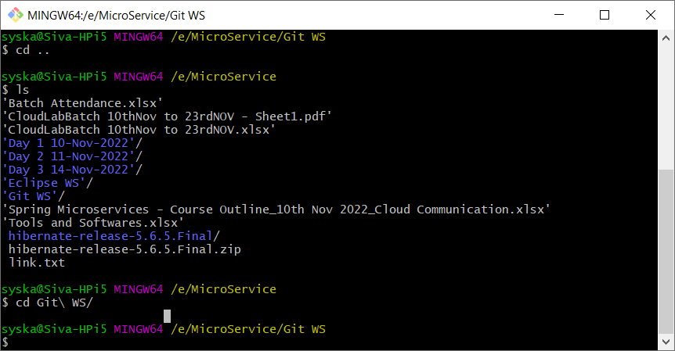

Initializing git local repository

Git init

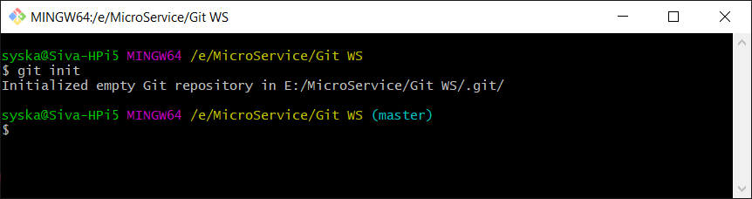

Create a new file namely “hello.txt” and enter few lines in it. Save the file.

Type “git status”

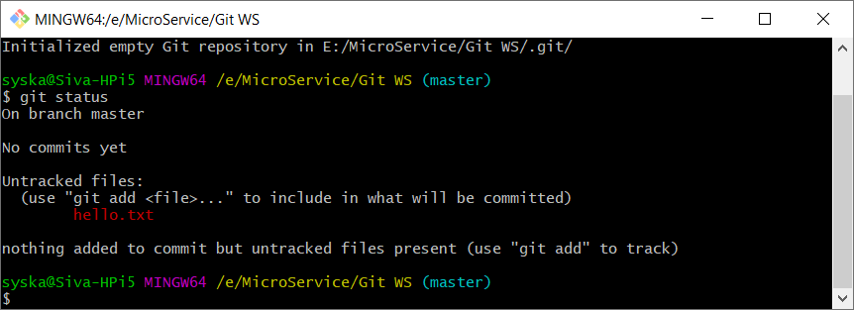

Type “git add hello.txt”

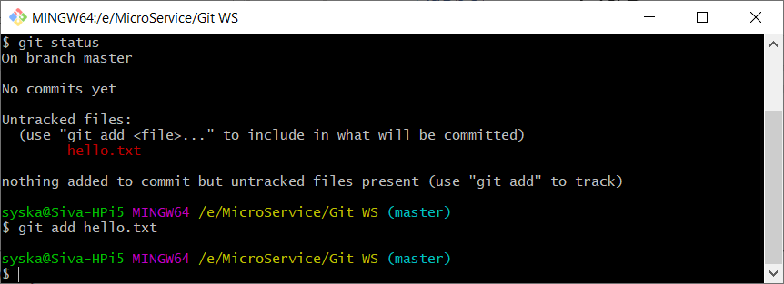

Type “git status”

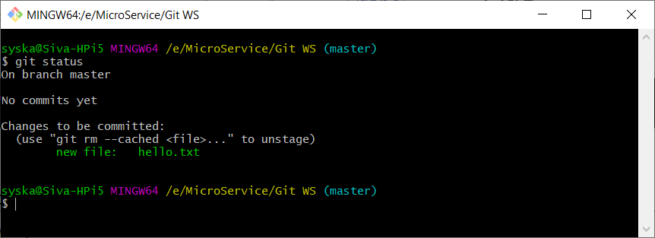

Add your email address and user name to git by using the following commands

Git config –global user.name “sivakumar os”

Git config –global user.email “[syskantechnosoft@gmail.com](mailto:syskantechnosoft@gmail.com)”

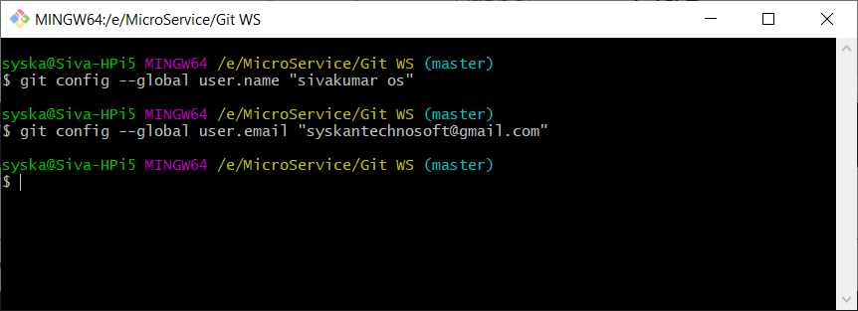

Type “git commit -m ‘first commit’” - to commit the file (Move the file to from staging area to local repository)

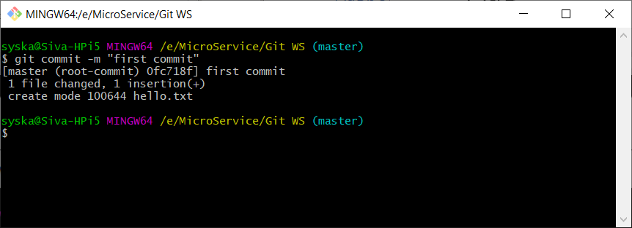

Type “git status” to check the commit status

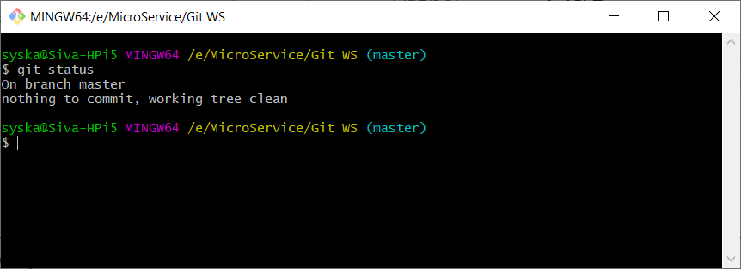

Open the hello.txt file add few more lines and save it.

Type “git status”

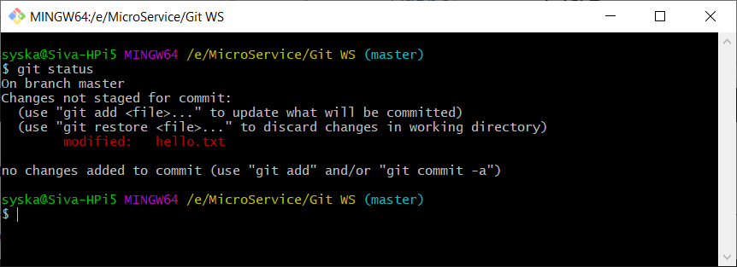

Type “git commit -m “second commit”

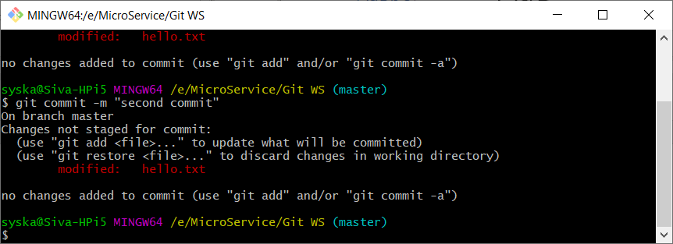

To add the changes to staging area and to commit the changes

Type “git commit -a -m “second commit2”

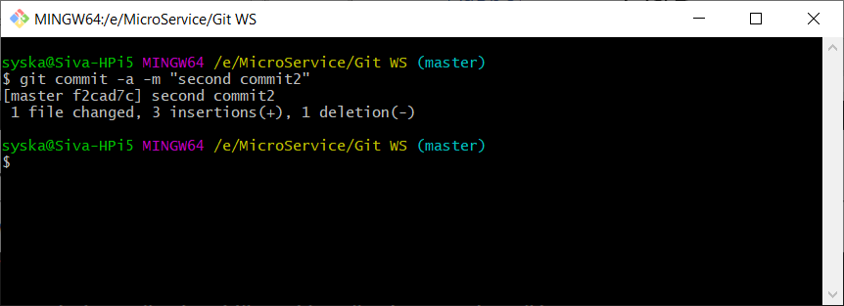

Type “git status”

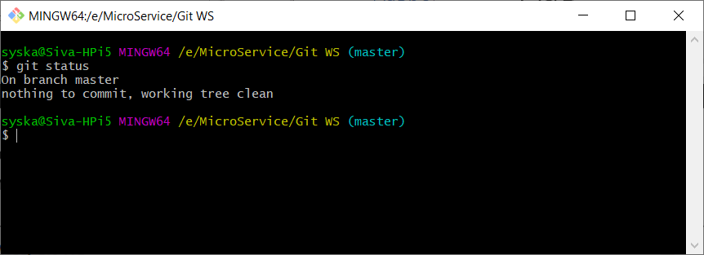

HEAD will be pointing to the recent commit (or Master branch)

Type “git log”

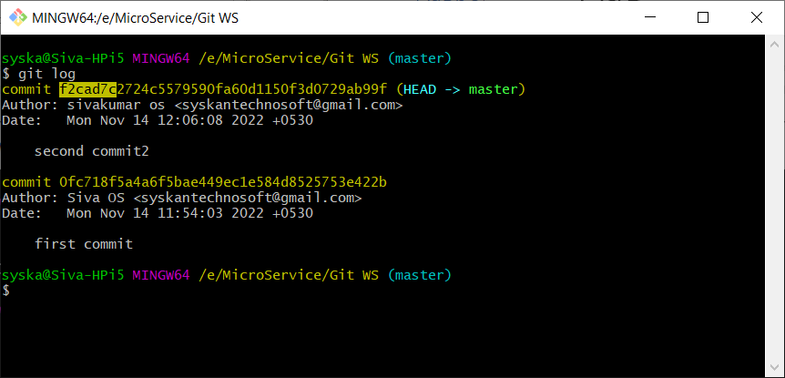

Create two folders inside GIT WS folder namely foder1 and folder2 and create a file in each folder.

Type “git status”

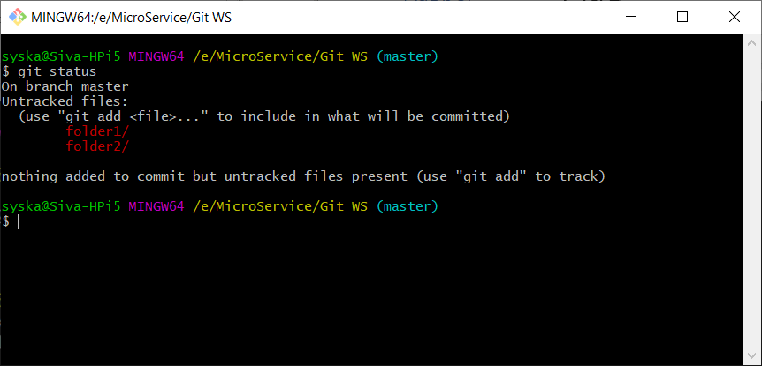

To start tracking these folders

Type “git add .”

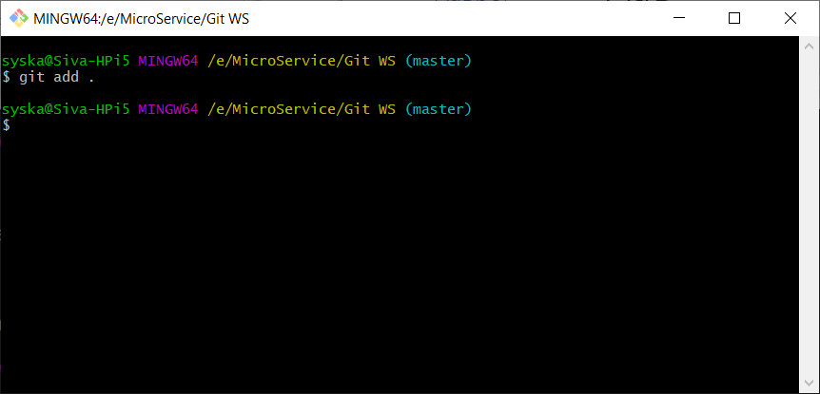

Type “git status”

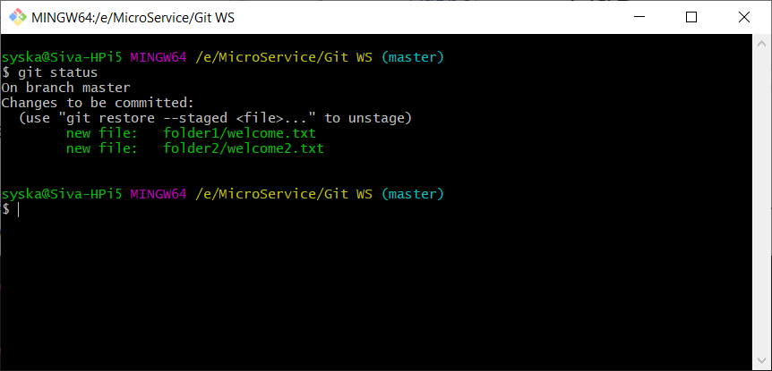

Type “git commit -m “folders added””

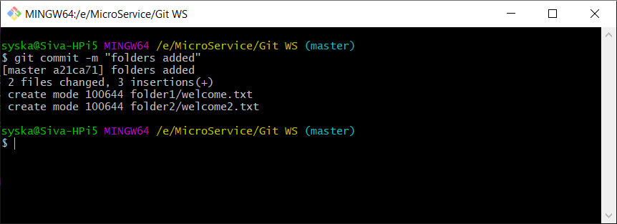

Working Area (Workspace) --🡪 Staging Area (Temp Loca) -🡪 Local Repository (Tracking starts)

Git add = Will move the resource to the staging area only

Git commit -a = Will add and commit the resource in the same time.

. in git add command represents contents of the current folder

Go and create an account in github site.

Github is a online git repository (It’s remote repository)

* GitLab
* Github (Microsoft)
* BitBucket

Commit is also called as Checkin

Pull or clone is also called as “Checkout”

Staging area is also called as Index Area

Files moved to this staging area is called as “staged files/cached files/current directory cache”

Forking – Creating a copy of remote repository with a different repo name (photocopy of a book) – online copy. (save as – Saving a folder with a new name in a different folder)

Cloning - Creating a local copy of remote repository folder.

Create a new Github account and create a new public repository in the name of “mydemo_repo”

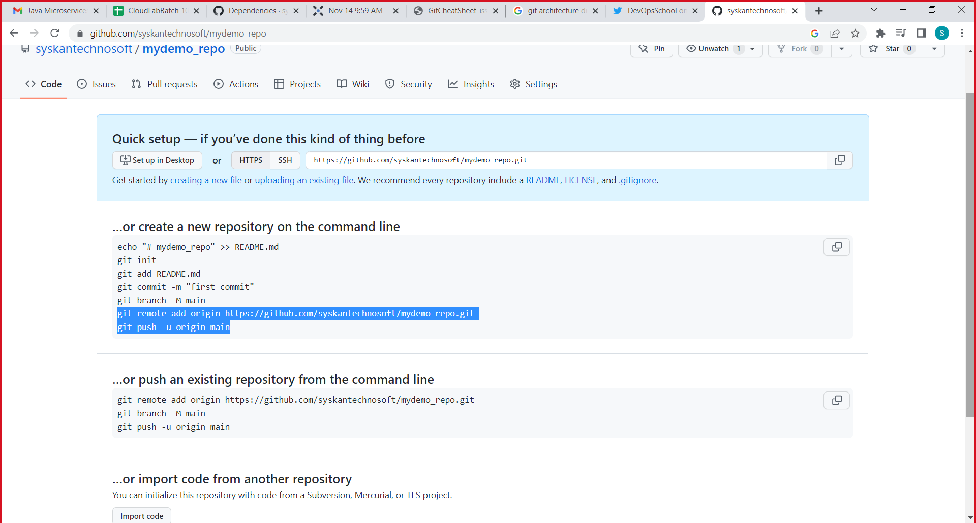

git branch -M main

git remote add origin https://github.com/syskantechnosoft/mydemo_repo.git

git push -u origin main

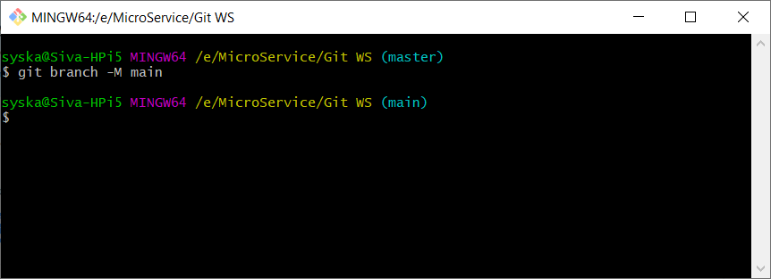

Type “git status”

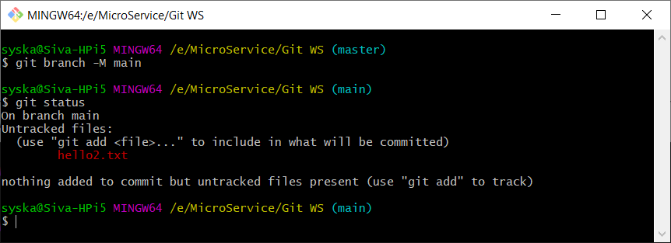

Type “git remote add origin https://github.com/syskantechnosoft/mydemo_repo.git”

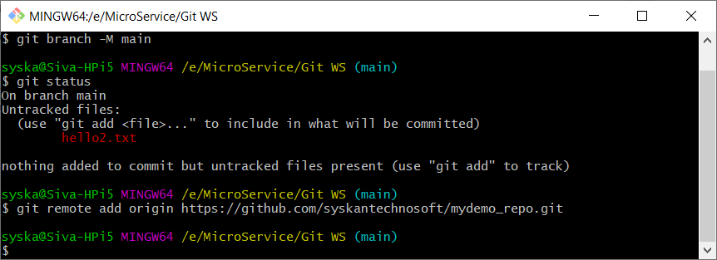

Git push -u origin main

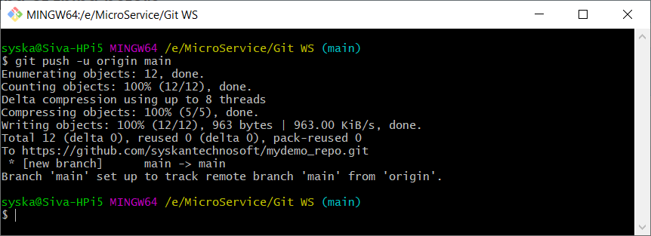

Type git status

Type git add .

Type git commit -m “adding hello2.txt”

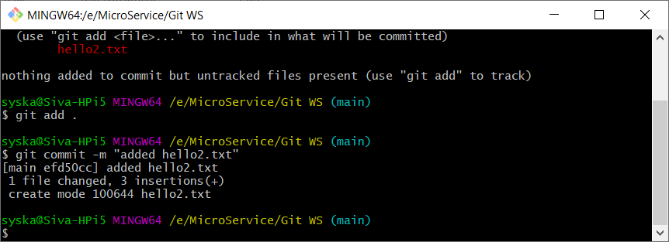

Git push -u origin main

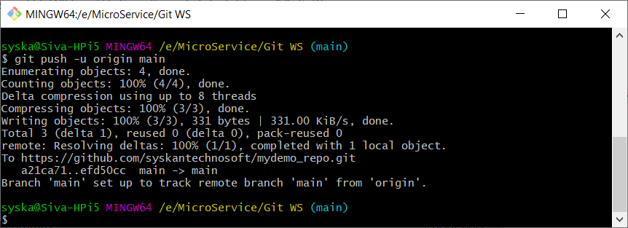

<https://githubtraining.github.io/training-manual/#/01_getting_ready_for_class>

Upload all the Day1 and Day2 codes to the github repo.

100 files can be added at a time. Each file size shouldn’t be more than 20 mb.

Git – Git is a Distributed Version Control Tool.

SVN, ClearCase, Perforce etc.,

Git is Open Source and Free Tool.

Git is very popularly used version control System.

Git is developed by Linus Torvalds.

Git commands unix and linux style commands.

Git is a important project management tool.

GIT is a SCM software (Software Configuration Management or Source Code Management)

Version control system, maintains and tracks the changes made to a software project.

Git can be downloaded and installed from official web site <https://git-scm.com/downloads>

Make sure to make the default editor of git as Notepad or Notepad++.

Git commands

1. Git init
2. Git clone
3. Git add
4. Git commit
5. Git push
6. Git Pull
7. Git branch
8. Git log
9. Git status
10. Git diff
11. Git reset
12. Git remote
13. Git rm
14. Git mv

Working Directory (Workspace)

Staging Area (Temporary Storage)

Local Repository (A Folder with Git folder in it) – Git track all changes in this place only.

Remote Repository (It’s Cloud/online resource to save all the files & folders of a repository)

In each commit, there will be hexadecimal hashcode, which uniquely identifies the commit.

Github – It’s online/cloud place to manage git repositories.

Creating a public/private repo. Adding files & folders to it.

Changing the visibility of a repo. Adding/inviting a collaborator to a repo.

Forking the repo

Cloning the repo.

<https://githubtraining.github.io/training-manual/#/01_getting_ready_for_class>